Decorating Template Method with Interfaces

Document Housekeeping
Prefer Composition over Inheritance should more explicitly be stated as:
Prefer both Interface Inheritance and Interface Composition over Class Inheritance.
As a prerequisite, for the documentation, the name Subtype Polymorphism is replaced with Interface Inheritance. This is to help the developer distinguish between the following terminologies:
- Class Inheritance
- Class Composition
- Interface Inheritance (Instead of Subtype Polymorphism)
- Interface Composition
For clarification, the remainder of the document will refer to inheritance as either class inheritance or interface inheritance. Further, the document will refer to composition as either class composition or interface composition. This distinction between classes and interfaces lends to our goal of coupling to abstractions rather than concretions.
When there is a box named:
- Parent.xxxxx, that means that the Parent Method will be called in the Child Method.
- Interface.Method, that means that the Parent.Method will be called here through the Interface DD method.
Each of the following sections have a dedicated LabVIEW project file, where the final UML diagram in the section has been created for the respective project.
- Interface Inheritance
- Interface Composition
- Interface Inheritance and Interface Composition
- ISP Simplification
- Strategy Pattern
- Template Method
- Advanced Logic Template Method

Replacing Class Inheritance with..
Prerequisite: Replacing Class Inheritance with Interface Inheritance and Interface Composition is outlined fully in this short video: Only Use Inheritance If You Want Both of These.
Class inheritance is where a child class inherits the functionality of the parent class. LabVIEW defaults the developer to having these checkboxes unchecked for DD methods in the parent class.
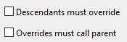
Though the default are unchecked checkboxes, these should be checked at all times to adhere to the SOLID principles.
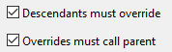
Specifically, the L in SOLID. The Liskov Substitution Principle (LSP): When extending a class, remember that you should be able to pass objects of the subclass in place of objects of the parent class without breaking the client code. This means, if you inherit from a class, you must fulfill all of the requirements of the parent.
The following are referred to as Misused Class Inheritance.Class inheritance is misused when either:
- Override Parent Method without Call Parent Method
  - Replace with Interface Inheritance
- Call Parent Method without Override Parent Method
  - Replace with Interface Composition
The following statement is referred to as Proper Class Inheritance. Class Inheritance should only be used when both:
- Overriding a parent method in the child (Override Parent Method) and calling that parent method (Call Parent Method) in the overridden method in the child.

Interface Inheritance
(1/2) Class Inheritance used for Override Parent Method without Call Parent Method..
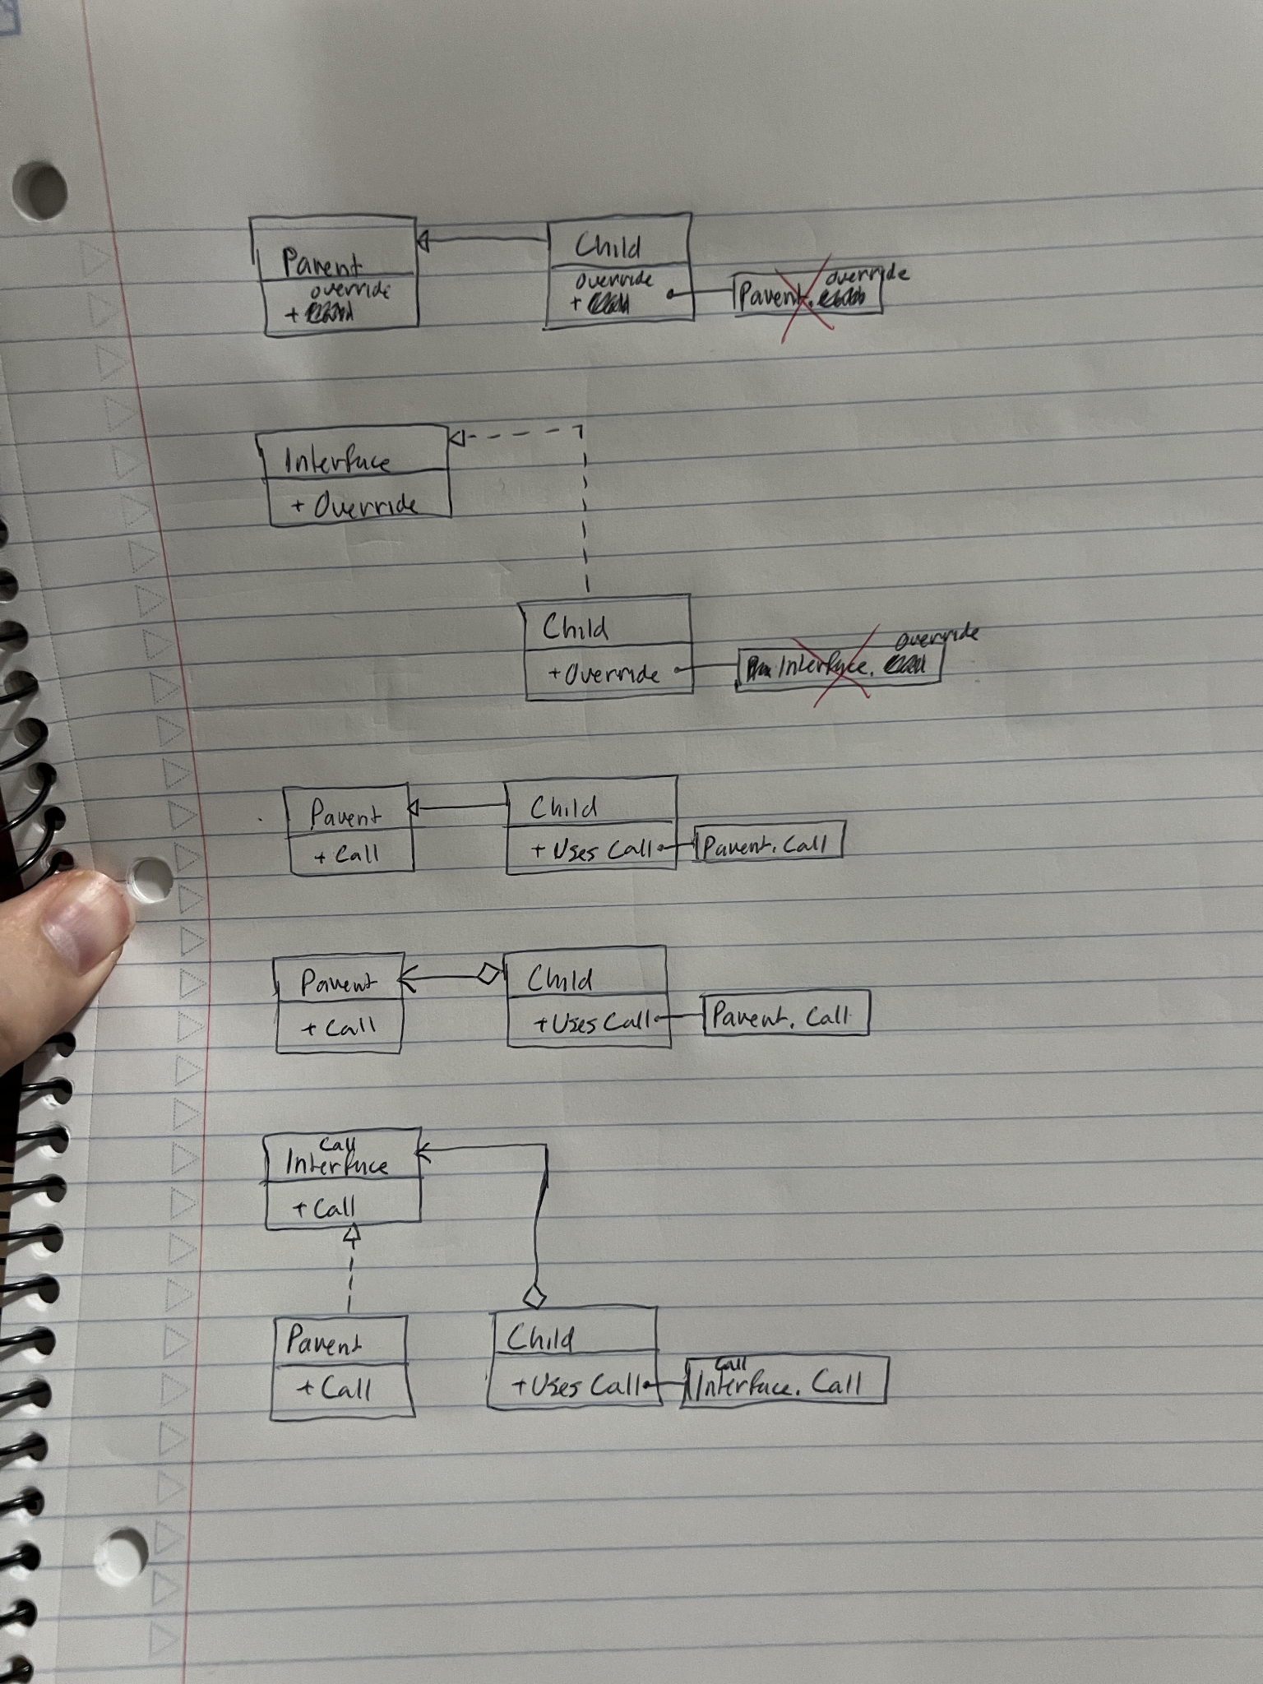

(2/2) ..should always be replaced with Interface Inheritance.

Interface Composition
(1/3) Class Inheritance used for Call Parent Method without Override Parent Method..

(2/3) ..should always be replaced with Class Composition..

(3/3) ..which should always be replaced with Interface Composition.

Interface Inheritance and Interface Composition
(1/4) Class Inheritance used for Override Parent Method and Call Parent Method..
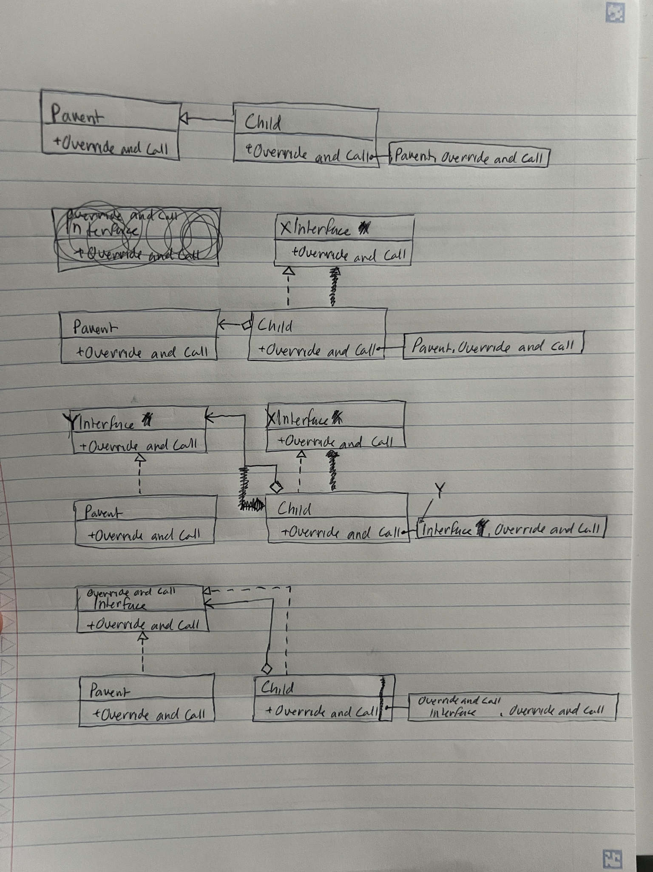

(2/4) ..could be replaced with Interface Inheritance and Class Composition..

(3/4) ..which should always be replaced with Interface Inheritance and Interface Composition..
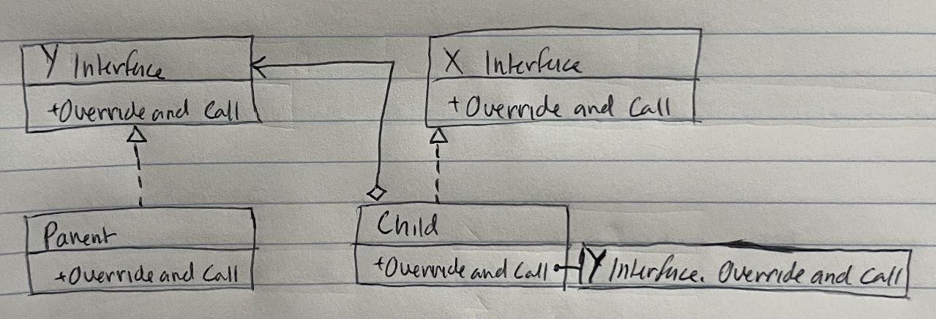

(4/4) ..and noticing the simplicity of X Interface = Y Interface, so combine X Interface into Y Interface and rename the Y Interface to Override and Call Interface..
This is the Decorator Pattern. Since the Override and Call Interface composed into Child is private, we must make a decorator (accessor) method to write in the Parent before calling the method.
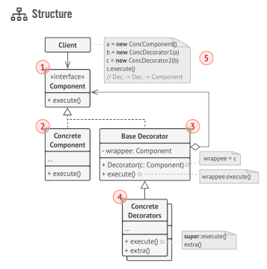
Dive into Design Patterns: Decorator Pattern (page 198)
For the following sections, Class Inheritance will not show up again for the document. The previous three sections on
- Interface Inheritance,
- Interface Composition, and
- Interface Inheritance and Interface Composition
replace Class Inheritance.

Refactoring Class Inheritance
As a side note for replacing Class Inheritance with Interface Inheritance and Interface Composition, we should still fulfill the class checkboxes:
As developers, We hold Interface Inheritance and Interface Composition to the same standard:
- Interface Inheritance. Keeping the default interface checkbox checked:
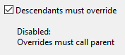
- Interface Composition. LabVIEW does not have any checkboxes to enforce that the developer calls the parent method in the overridden method. Therefore, if a method is overridden with Interface Inheritance, it is the developers responsibility to Call Parent Method in the override.

ISP Simplification
(1/1) Replace Interface and Method with Interface 2 and Method 2. Then add Interface 1 and Method 1 (This is to follow the I in SOLID, Interface Segregation Principle)..
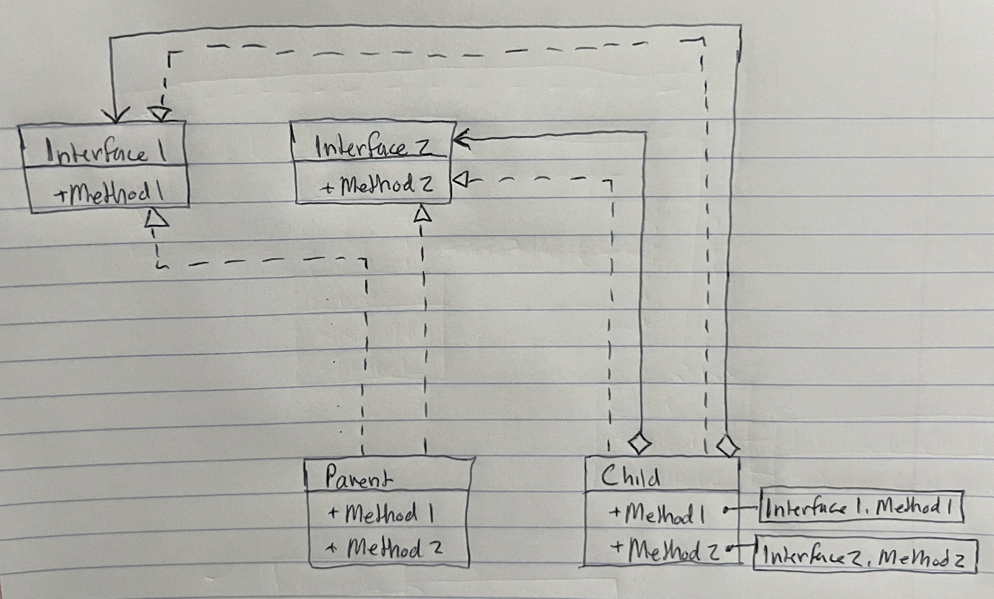
(2/2) ..add Interface for simplicity..
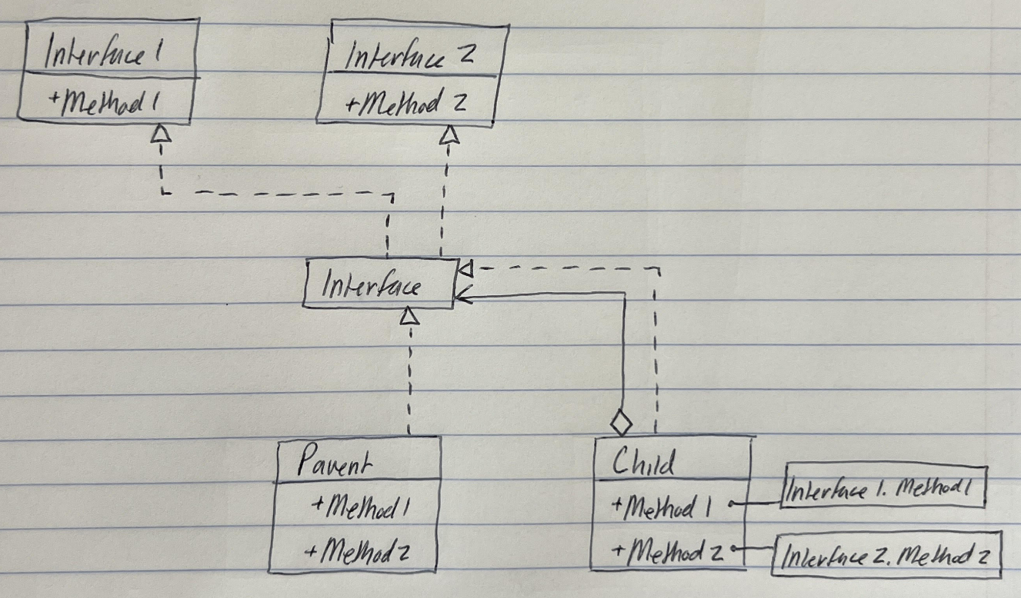

Strategy Pattern

Template Method
Starting with Class Inheritance Template Method.. we see three sections for this:
- Call
- Override
- Override and Call
- Template
**notice that Override is not present here because it is our responsibility to call the parent method in any overridden method.

Advanced Logic Template Method
- error statements
  - No Error: if interface is inherited in Child then do normal decorating Parent with Child.
  - Error: otherwise, Read Interface to unbundle Child
- the use case of error statements: have this error statement within Msg Receive as well to properly decorate or not decorate the emessage
this is done to help Child does not need to override methods it will not use
Error tells if interface message has been overridden in the actor:
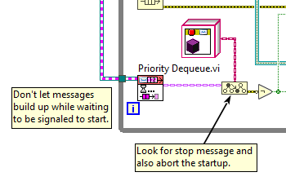
Flipped logic as:
-Always call the parent method
-unless the Child implements the interface then call the Child method (inside the Child method, the COULD be the parent method which is decorated

Decorator:
Not every parent method needs to be called in the overridden method! In documentation, the first line mentions if the parent method is MANDATORY that some be called in the override method.
Example with Template Method:
Override and Call
Override and Call (Two)
Call
Call (Two)
Override
Override (Two)
If you’re dumb and do not call the parent method in the override, then the framework handles the releasing of resources for you.

More Information

General Template Method Refactoring
https://stackoverflow.com/questions/669271/what-is-the-difference-between-the-template-method-and-the-strategy-patterns
https://softwareengineering.stackexchange.com/questions/171626/combining-template-method-with-strategy
https://www.google.com/amp/s/slideplayer.com/amp/9233646/

Go Template Method Refactoring
Go does not allow the use of inheritance in their language, so following the refactoring of template method, we can look into how their language solves this problem.
Here are some useful sources:
https://www.google.com/search?q=go+templte+method&rlz=1C1CHBF_enUS922US922&oq=go+templte+method&gs_lcrp=EgZjaHJvbWUyBggAEEUYOTIICAEQABgWGB4yCAgCEAAYFhgeMggIAxAAGBYYHjIICAQQABgWGB4yCAgFEAAYFhgeMggIBhAAGBYYHjIKCAcQABgPGBYYHjIKCAgQABiABBiiBDIKCAkQABiABBiiBNIBCDI2OTdqMGo3qAIAsAIA&sourceid=chrome&ie=UTF-8

Refactoring Book
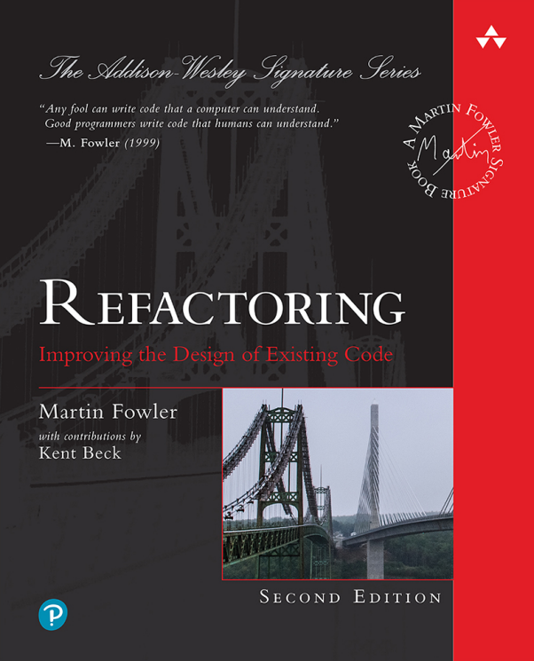
Moving from Inheritance to subtype polymorphism and composition follows the “Replace Superclass with Delegation” section from the book Refactoring by Martin Fowler (page 447).
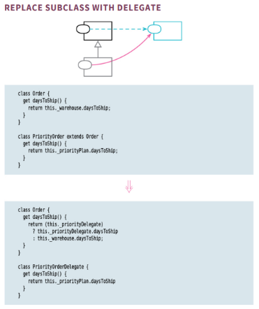

There could be some merit with instead using the first approach to the right where instead you compose in the child to the parent instead of the other way around (page 423)
